Exp No: 26
TRANSACTION LEVEL MODELING (TLM) USING SYSTEMC
AIM:
To model and simulate a simple Transaction-Level Model (TLM) using Initiator and Target modules in SystemC
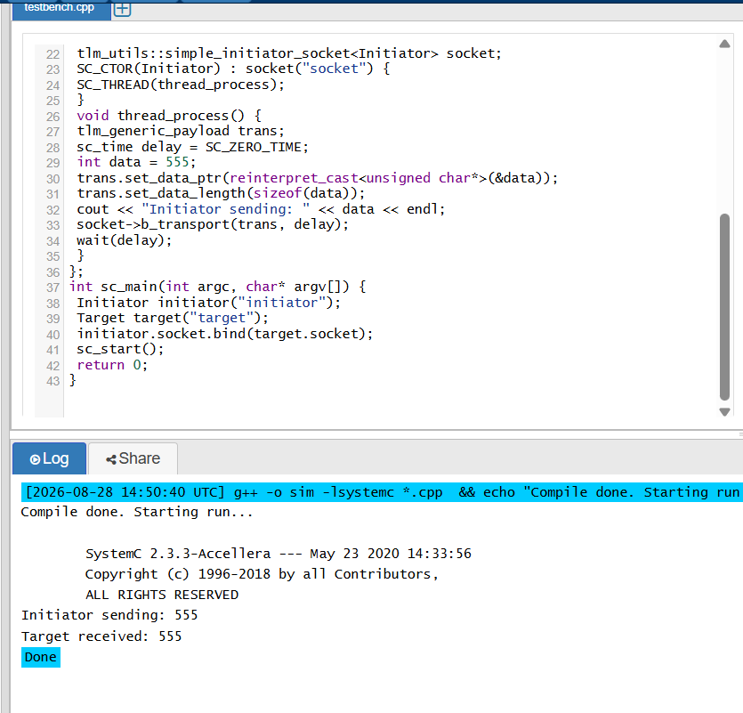
RESULT: Thus the Transaction-Level Model using Initiator and Target modules was successfully implemented and simulated using SystemC

